Aathirai K

Content writer , Script writer , Ai works

WORK EXPERIENCE

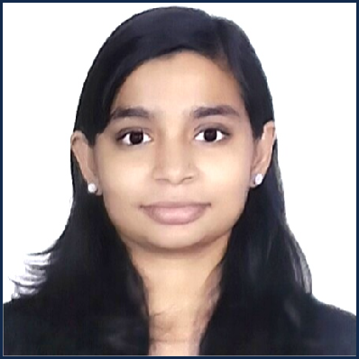

Happy Hostel , Porur, 600116 Po rur, IN,

+91 8375998994

aathirai150304@gmail.com

PROFESSIONAL SUMMARY
Creative and results-driven Content Writer & Social Media Manager with expertise in content creation, marketing, social media strategy, and team leadership. Skilled in developing engaging, audience-focused content, managing digital platforms, and implementing AI-driven marketing strategies that enhance brand visibility and engagement. Proficient in content planning, social media analytics, project management, and data-driven decision-making to deliver measurable growth. Passionate about combining creativity, innovation, and strategic thinking to create impactful brand experiences and drive sustained business success in dynamic media and marketing environments.

SKILLS AND INTERESTED
Communication Skill Team Management Skill Time Management Skill Creative problem-solving Deadline management
Engaging In Group Work Skill Project Management Skill
Jun 2025 — Aug 2025
Content writer & Social Media Manager, Shreevarma Ayurveda

Manapakkam
- Crafted targeted content to enhance audience engagement and improve brand consistency across digital platforms.
- Orchestrated social media campaigns that increased follower interaction and elevated overall brand visibility.
- Monitored content performance metrics to optimize messaging strategies and boost campaign effectiveness.
- Collaborated with cross-functional teams to align content initiatives with marketing objectives and customer needs.
- Refined editorial processes to ensure content accuracy, tone consistency, and timely publication.

Nov 2025 — Mar 2026
Junior Executive - Marketing Communication, Black Coffee Brands

Koyembedu
- Created and distributed marketing communications to ensure consistent brand messaging and improve customer engagement across channels.
- Coordinated with cross-functional teams to align marketing materials with campaign objectives, enhancing overall message clarity and impact.
- Monitored and reported on campaign performance metrics to identify areas for content optimization and increase audience reach.
- Managed content calendars to streamline delivery schedules and maintain timely publication of promotional materials.
- Collaborated with vendors and external agencies to secure high-quality creative assets, ensuring compliance with brand standards.

EDUCATION
Jan 2022 - Dec 2025
BSc. Animation & Visual Communication, Dr. M.G.R. Educational & Research Institute

HSC, THE LAWRENCE PUBLIC SCHOOL , NEW DELHI New Delhi

SSLC, THE LAWRENCE PUBLIC SCHOOL , NEW DELHI New Delhi

LANGUAGE

Tamil English
Leadership Skill Content writer & creator Marketing
Ai Works
Social Media Manager Dubbing
Journalism Camera Handling Content Strategy Audience Analysis
Direction & Production Management Audience targeting
Strategic planning Content scheduling
Hindi

LINKS

Aathirai Portfolio

EXPERIENCE
Feb 2025 - Mar 2025
Experience Internship, Puthiya thalaimurai channel New generation media
During my internship, I gained hands-on experience in media operations, content production, and broadcasting workflows while developing proficiency in AI-powered tools such as Hailuo, HeyGen, Perplexity, and Leonardo AI for content creation, research, visual design, and workflow optimization. I acquired practical knowledge of PCR (Production Control Room) and MCR (Master Control Room) operations, along with foundational skills. Collaborating with cross-functional teams, I contributed to content and production-related projects, strengthening my communication, teamwork, and problem-solving abilities while gaining valuable exposure to media production, content strategy, and broadcast operations in a fast-paced professional environment.

HOBBIES
Music , Novel Reading , Arts & Paintings , Calligraphy , Travelling

