CURRICULUM VITAE

AZHAGIRI.G
er.azhagiri@gmail.com 9566880961

OBJECTIVE

Willing to work as a key player in an innovative environment which will help me to explore myself fully and realize my potential.

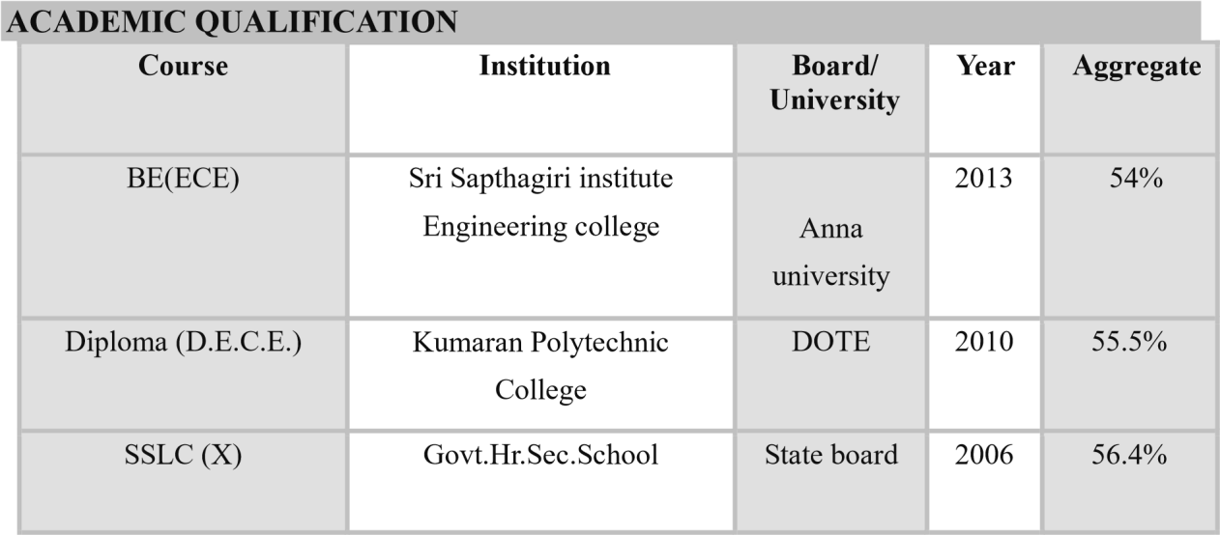

AREAS OF INTEREST

- Telecom
- Marketing
- Sale
- Utility industrial plant maintenance
- Industrial safety
- Administration

EXPERIENCE

Organization : SARGAM CATHODIC PROTECTION LLB
Duration : SEP-2026 to Till date
Occupation : Field service Engineer
Job Responsibilities

Key Responsibilities

Installation & Commissioning
- Install and wire ICCP control panels onboard ships or offshore platforms
- Connect anodes, reference electrodes, and power supply systems
- Perform system calibration and initial testing
- Monitor output voltage and current readings
- Inspect reference electrodes and hull potentials
- Troubleshoot panel alarms and system faults
- Replace defective components (rectifiers, PCB boards, fuses, etc.
- Install and commissioning MGPS equipment on ships and offshor
- Monitor MGPS performance and adjust system settings as required
- Inspect anodes, electrodes, control panels, and cabling
- Carry out routine maintenance and replacement of consumables
- Troubleshoot MGPS faults and electrical issues
- Ensure proper dosage and system effectiveness as per manufacturer guidelines
- Coordinate with ship crew, shipyard teams, and service engineers
- Prepare vessels for dry docking and undocking operations
- Inspect hull, propeller, rudder, sea chests, and underwater fittings
- Carry out steel repairs, welding, blasting, and painting activities
- Coordinate with electrical and instrumentation teams
- Follow safety procedures and permit-to-work systems
- Maintain daily work progress reports and documentation
- Coordinate with ship owners, surveyors, and subcontractors
- Ensure timely completion of dry dock projects within budget

- Organization : Monolisa Manpower management
(Gilbarco veeder root)
- Duration : 18-NOV-2024 To June 2025
- Occupation : Field service Engineer

Key Responsibilities,

Fuel Dispensing Unit & Retail Outlet Automation Services
Field.

1.Ensure that all activities are carried out safely in accordance to all relevant country specific Health & Safety
legislation and Gilbarco Vedder Root HSE policy/ procedures.

2. The associate is personally responsible for contributing to a safe working environment by maintaining an
orderly work area and proactively raising safety concerns.

3.Ensure that all training and qualifications necessary to perform work tasks are identified in a timely manner and that no activities are undertaken without suitable competence.

4.Carry out preventive maintenance.

5.Carry out breakdown jobs assigned.

6.Update spares requirement.

7.Collect the spares from courier office / Service centre and resolve the complaint immediately on receipt of spares.

8.Ensure resolution of complaints in the lst visit itself.

9.Return defective spares to stores within 7 days of closure of complaint.

10.Return unused ok spares immediately to the stores department.

11.Provide feedback to the CSD immediately after closure of complaint.

12.Submit all Breakdown service reports to ASM/Stores and Preventive maintenance reports to Commercial Executive on a weekly basis.

13.Report non-compliance issues if found being practices in the system to supervisor or use Speak up opportunity provided by the company.

14.Perform installation, repair and maintenance tasks on equipment and infrastructure at customer/partner sites primarily the retail fuel outlet. Flexibility is required to address customer needs, identify the problem at site and
ensure timely completion of the Job in a safe and secure manner.
Gilbarco Vedder-Root (GVR) requires that all associates comply with the GVR Health, Safety and Environment (HSE).

15.Policy as well as the Vontier Standards of Conduct.

16.Internal,Service Manager,Team leader,Call Handlers/dispatchers,Helpdesk/Technical Support,Other field engineers,External Customers,Petrol Pump Dealers,Subcontractors,Members of the public
Planners.

16.Interaction with installation/project manager & project coordinator where applicable

- Organization : Indus Towers Limited
- Duration : Sep 2023-To Dec 2024
- Occupation : Field support engineer

Job Responsibilities:
  - Outage on Non-DG sites
  - Outage due to Access issue sites
  - Owner/Neighbors issues to run the site/infra equipment (DG)
  - Thefts of Infra equipment's (Battery Bank, Diesel, DG battery)
  - Under rated/aged equipment's
  - Sites near International borders
  - Uncertainty of EB power cuts and poor quality
  - Climatic issue (Rainy season/Flood/Cyclones)
  - Owner captured sites.
  - Material constraints
  - Ensuring availability of technicians on ground by the IME/SME/ OME Partner
  - Ensure timely delivery of project activities having required quality and AT standards!

ESH Compliance
- Site Hygiene; compliance to organizational requirements
- Adhering to SOPS
- Ensuring correctly rated equipment's
- Ensure use of PPE by self and technicians
- Support in regular training on ESH and ensure that safe practices are being following at Tower Site 6. Ensure issue and usage of PTW for every activity being done at a site."

Customer Management
- Provide supports for outage escalation by OPCOS
- Site access supports as and when applicable for tenants
- Maintain healthy customer relationship
- Supervise Site upgrades as per specification and provide support for RFS activities."
Site Quality & process compliance
- Maintain excellent level of site quality (proper cable laying, correct temperature, correct settings, site in Auto, etc.)
- Identify Gap against specification and ensure timely corrections
- Periodic audit to ensure that civil/tower electrical and other Infrastructure are in the best state.
- Ensure ZERO quality/operational process noncompliance
- Compliance checking of quality of technicians, partners, spares including any ethical issues."

Energy Management
- Identifying high Diesel consumption sites and recommending their remedy action
- Minimizing EB faults
- Facilitating in converting non-EB sites to EB sites
- DCEM Compliance
- DG running hrs. compliance.

Uptime
- Drive Uptime for all Customers. Maintain infra uptime as per MSA/KPI's
- RCA of outages and prepare corrective action plan to avoid repetitions.
- 100% Site Automation and Alarm integration with NOC. Alarm & Metering correction at Site.
4.100% compliance on PM
5. Site visit and closure of punch points"

Team Management
- Technician performance evaluations
- Identify training needs of technicians and plan for development
- Site allocation, discipline management for technicians"
4.Drive Uptime for all Customers. Maintain intra uptime as per MSA/KPI's
5.RCA of outages and prepare corrective action plan to avoid repetitions.
6.100% Site Automation and Alarm integration with NOC. Alarm & Metering correction at Site.
7.100% compliance on PM
8.Site visit and closure of punch points"
•Landlord Management
- Compliance of sites access process
- Maintains high level of landlord engagement to ensure 24*7 access and facilitate upgrade / planned event / installation and other operational work at site
- Resolution of hygiene related trouble tickets to ensure landlord satisfaction." Strong Knowledge: Knowledge of DG sets, AC power
management system, DC power management system, Battery backup system, HVAC, antenna & basics of GSM/CDMA technology will be added advantage"

- Client : Airtel Payment Bank
- Organization : V5 Global services Pvt Ltd
- Duration : 1st dec 2019- To sep 2023
- Occupation : Field Sales Executive

Field sale Experience
- Achieving sale target
- Creating fastag account and achieving day target
- Weekly target and monthly target of sale
- Marketing of the Fastag sale

EXPERIENCE

Client : Bharti Airtel Chennai
Organization : Absortherm Facility Management Pvt Ltd
Duration | : 1st April 2014 – 1st Feb 2016
Occupation | : BMS Operator
JOB PROFILE:

- To monitor the building management system (BMS) for alarm. To carry out a remote fix to remote alarm.
- Responsible for proactively identifying improvements to system in order to reduce BMS related systems failures and to improve the efficiency.
- Respond to queries regarding issues at site.
- Maintain accurate records of all tasks and taken.
- Maintenance of Shift activities follow-up and handling of breakdown.
- Operation and maintenance of GBFSS, VESDA, WLD and RRS system.
- Monitoring UPS and power plant and transformer  Generating Access report.
- Call log with vendors for complaints.
- Testing BMS equipment during preventive maintenance.
- Maintaining CCTV, and its reports.
EXPERIENCE
Client | : Bharti Airtel Chennai
Organization | : Updater service Pvt Ltd
Duration | : 24th Oct 2013 to 31st Mar 2014
Occupation | : Technician
JOB PROFILE:

- Operation and maintenance of120 KVA *10ups
- Operation and maintenance of 2500KVA * Transformer
- Operation and maintenance of VCB circuit breaker 11KVA
- Operation and maintenance of MV PANEL & Air circuit breaker of 4000A
- Operation and maintenance of HT and LT panels
- Operation and maintenance precision control units for data centers
- Operation and maintenance of AHU
- Operation and maintenance of 15000 KVA DG sets
- Operation and maintenance of DC Power Plant System Delta

HOBBIES
- gardening
- Traveling

PROJECT
SPEED CONTROL OF INDUCTION MOTOR USING FUZZY PI CONTROLLER.
PERSONAL DETAILS
Father’s Name | : | C.GOPI
Mother’s name | : | C.VIJAYA LAKSHMI
Nationality | : | Indian
DOB | : | 05/01/1991
ADDRESS | : | #24 MARIYAMMAN KOIL ST  GEMMANGKUPPAM,  DEVARISHIKUPPAM POST, KATPADI, VELLORE.
Languages known (To write) | : | Tamil, English
(To speak) | : | Tamil, and English, Telugu
Mother Tongue | : | Tamil
DECLARATION

I hereby declare that the information furnished above is true to the best of my knowledge.
Place: Chennai Signature

Date: (AZHAGIRI.G)

