CURRICULAM VITAE  Name –Ankit kumar Sharma  B.Tech (ECE)  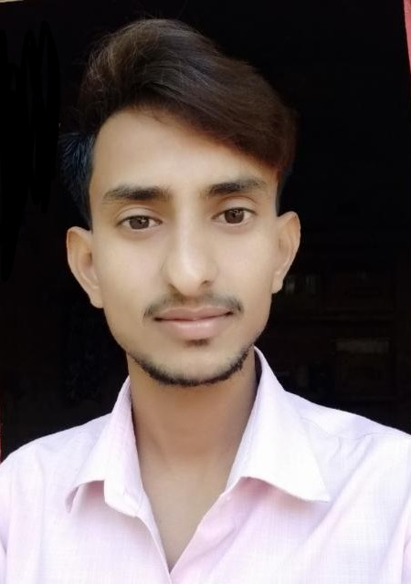  Address:  Vill- itkauli,post- Saifullagunj , distic -sultanpur UP 228119  Mobile:-6392221460  Email Id:- ankitsharma5054@gmail.com | CAREER OBJECTIVE  - Dedicated maintenance engineer with 3 year of experience and degree engineering makes me the perfect fit for any company.  - Versatile the result oriented individual with through knowledge of all the kinds of equipment used in a company.  - A persistent performer skilled to perform no of high level task with efficiency and effectively.  ACADEMIC RECORDS  INDUSTRIAL TRAINNING  COMPANY NAME – BHEL JAGDISHPUR.  PROJECT TITLE – APPLICATION OF CONTROL AND INSTRUMENTATION IN STRESS RELIEVING FURNACE.  DURATITON – 29 DAYS.  - Automatic Street Light.  - Electrical Appliences Control System Using Cell Phone.  LANGUAGES KNOWN  - English and Hindi.  WORK EXPERIENCE  - I have 2.5 year experience in Sunwoda Electronic India Pvt Ltd as a Maintinance Engineer.  - IDEMIA Syscom India Pvt Ltd as a Maintinance Engineer From 2/01/2023 to 18/08/2023.  - Current working with Giesecke derivative ms india pvt ltd as a Maintinance Engineer from 01/09/2023 to till now .  RESPONSIBILITY & SKILL  - Maintaining and reparing automatic machine required in the day to day working.  - Assessment of the required tools of the maintenance as and when required.  - Analysis the machine failure.  - Replacing the spare parts of the machine as and when required.  - Responsible of performing routine maintenance.  - Equipment important and difficult problem solving.  - Servo motor.  - Stepper motor.  - Sensor troubleshooting and good knowledge of electricals.  - Must aware about reporting skill for machine breakdown and machine improvement.  - Why why Analysis. MTTR & MTBF & good TPM working good experience  - Production line and machine setup and changeover.  - Knowledge about PLC hard wiring as well as servo drive , stepper drive and vfd connection.  - Knowledge about pneumatic operation and uses parts.  - Knowledge about Microsoft word and Microsoft Excel  - Flexibility.  - Adaptability.  - Self-Motivated.  - Problem solving skill.  - Skills to improve FPY rate.  - Skills to improve Zero defect drive.  - Electronic Circuit.  - Switching Theory & Logic Gate  HOBBIES  - Listening music.  - Internet browsing.  - Playing games.  EXTRA CURRICULAR ACTIVITIES  Participates in PSIT Kanpur entrepreneurship Programme conduct by IIT KHARAGAPUR.  CAPABILITIES  Self-motivated, skill in problem solving, conflict resolution and quick learner. Capable of working with equal pace and accuracy under mental stress and pressure.  PERSONAL INFORMATION  Father’s Name - Mr. Rajesh Kumar Sharma  Mother’s Name - Mrs. Vimla Sharma  Date of birth - 07-april-1996  Gender - Male  Nationality - Indian  Religion -Hindu (OBC)  DECLARATION  I hereby declare that the information given above is true and correct to the best of my knowledge.
  COURSE | UNIVERSITY/ BOARD | YEAR OF PASSING | % OBTAINED
  B.Tech (Electronic and communication) | Dr. A.P.J. Abdul Kalam Technical University | 2019 | 64.5%
  Intermediate | U.P. Board ALLAHABAD | 2015 | 54.8%
  High School | U.P. Board  ALLAHABAD | 2013 | 70.8%
  ACADEMIC PROJECT
  CORE STRENGTH
  SUBJECT OF INTEREST

Date:- Signature:-

