WORK EXPERIENCE SKILLS

Digital marketing specialist Bangalore I start upcompany
- -
Digitalmarttetlng,website des.gNng.graphic designing.
social nwdia manager,add campa.gn SJ)Klalist. bursMSs
growth | rat est. | SEOSPKJaliSt

10/2021·12/2023
.•...Around 2years.i hadsuccessfully doM wil!l 70+dlents
buisnesses

Digital marketing specialist Bangalore I Startup company
10/2021. 12/2023
Ach;evements/Tasks
- I had successfully donewith70•tllents bulsness andlast year i got a bestdigital marketing strateglest award
PERSONAL PROJECTS

Dynamic digitalmarketing (12/2021·03/2022)
- Successfullycompleted theabroad ?reject

Social media manager (10/2021• 11/2023)
- 10xengage andgrowthesocialmediaof Polanddient

EDUCATION COMMUNICATION SKILL

Diploma in digital marketing National institute of digital marketing I bangalore
01/2021·06/2021
COU<Se
- Diploma in digital
marketing

LANGUAGES KNOWN :

Tamil, English
I excellent in communication, effectively conveying Ideas and actively listening, fostering strong collaboration and understanding in proffesional way of thinking

LANGUAGES

Tami!and English
FuM Professional. Proficiency

INTERESTS

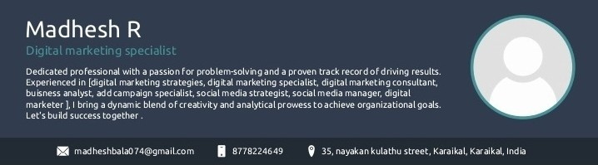
Responsibilities: staying updatod on Illelatestdiglal martttingstrategies
and trends,exploMgnewdigtal hights and learning new
l!llngs

Campaign Management, BTL & ATL activities, budget planning, analytics and reporting, adscreation, lead generation,
performance marketing, Brand awarness Google Ads, PPC, Facebook Ads,

