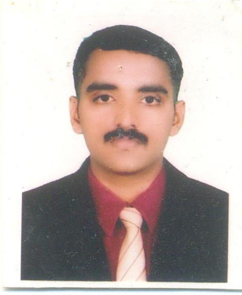
CURRICULUM VITAE

Name : RINJU KIRAN. P.V.
Father’s Name : P. Krishnan
Address : ‘Dwaraka’
Chenoth, Vellur-P.O.
Payyanur-Via, Kannur Dt.
Kerala - 670 346
Contact Phone No. : 9995756584
E-mail ID : rinjukiran@gmail.com
Date of Birth : 12-05-1984
Sex : Male
Nationality : Indian
Marital Status : Single
Languages Known : English,Hindi, Malayalam

Educational Qualifications :

- S.S.L.C. from Board of Public Exams, Kerala with 73.8% in 1999.
- Diploma in Electronics from State Board of Technical Education, Kerala with 58.57% in 2003.
- Plus Two from National Institute of Open Schooling, NOIDA with 54% in 2013.
- Degree in BA English from Annamalai University

Additional Qualifications :
- T.V. Mechanic Course (conducted by Continuing Education Cell, Govt. College of Engg. Kannur.)

- One year training in Audio& Video Service (Comtech Training Centre, Kannur).

- Certificate course in Pagemaker, Corel draw 9, Photoshop 7,Adobe Illustrator 11.

- Project work in Pentium-111 PC.

Experience

* Six year experience as service engineer in Geepas Electronics(Kannur)

* Four and half Year Experience as Service Engineer in Point Blank Range Pvt Ltd, Okhla Phase 11, Newdelhi

* Seven year experience as a Business Development Executive in Norisys Technology Ltd. (Kannur, Kasaragod)

* Two year experience in RJ Enterprises (IT& Electronics) Kannur, Kasaragod

*. Presently working as a Sales officer in Honeywell Electricals ( kannur, Kasargod )

Hobbies
Pencil Drawing

Driving Licence

- Number : TP/3945/06
- Class of vehicle : Motorcycle with gear
- Date of validity : 19-06-2026

Date : RinjuKiran. P.V.

